1. Identification of the substance/mixture and of the company/undertaking

1.1. Product identifier

Product Identity | Phoenix Adhesive Remover
Alternate Names | Phoenix Adhesive Remover

1.2. Relevant identified uses of the substance or mixture and uses advised against

Intended use | See Technical Data Sheet.
Application Method | See Technical Data Sheet.

1.3. Details of the supplier of the safety data sheet

Company Name | Phoenix Floor Care
 | 850 Boston Street SE
 | Grand Rapids, MI 49507
Emergency
CHEMTREC (USA) | (800) 424-9300
Customer Service: Phoenix Floor Care | 616-698-9240 (Phone)  616-698-9243 (Fax)

2. Hazard identification of the product

2.1. Classification of the substance or mixture
Physical Hazards Flammable liquids Category 3
Health Hazards Germ Cell mutagenicity Category 1B
Carcinogenicity Category 1B
Aspiration Hazard Category 1

Environmental hazards Not Classified

OSHA Defined hazards Not classified

2.2. Label elements
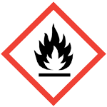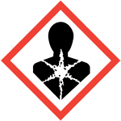
Signal word: Danger

Hazard Statement: Flammable liquid and vapor. May be fatal if swallowed and enters airways. May cause genetic defects. May cause cancer.

[Prevention]:
Obtain special instructions before use. Do not handle until all safety precautions have been read and understood. Keep away from heat/sparks/open flames/hot surfaces. –No smoking. Keep container tightly closed. Ground/bond container and receiving equipment. Use explosion-proof electrical/ventilation/lighting equipment. Use only non-sparking tools. Take precautionary measures against static discharge. Wear protective gloves/clothing/eye protection/face protection.

[Response]:
If swallowed: Immediately call a poison center/doctor. If on skin (or hair): Take off immediately all contaminated clothing. Rinse skin with water/shower. If exposed or concerned: Get medical advice/attention. Do NOT induce vomiting. In case of fire: Use appropriate media to extinguish.

[Storage]:
Store in a well-ventilated place. Keep cool. Store locked up.

[Disposal]:
Dispose of content/container in accordance with local/regional/national/international regulations
3. Composition/information on ingredients

Substances
Chemical name Common name and synonyms CAS number %
Naphtha (Petroleum), 64742-48-9 100
hydrotreated heavy
4. First aid measures

4.1. Description of first aid measures

General | In all cases of doubt, or when symptoms persist, seek medical attention.  Never give anything by mouth to an unconscious person.
Inhalation | Remove to fresh air. Call a physician if symptoms develop or persist
Eyes | Immediately flush eyes with plenty of water for at least 15 minutes. Remove contact lenses, if present and easy to do. Get medical attention if irritation develops or persists.
Skin | Remove contaminated clothing. Wash skin thoroughly with water/shower. Get medical attention is irritation develops or persists.
Ingestion | Call a physician or poison control center immediately. Rinse mouth. DO NOT induce vomiting. If vomiting occurs, keep head low so that stomach content doesn’t get into lungs.

4.2. Most important symptoms and effects, both acute and delayed

Overview | Aspiration may cause pulmonary edema and pneumonitis. Direct contact with eyes may cause temporary irritation.
Indication of immediate medical attention and special treatment needed | Provide general supportive measures and treat symptomatically. Thermal burns: flush with water immediately. While flushing, remove clothes which do not adhere to affected area. Call an ambulance. Continue flushing during transport to hospital. Keep victim under observation. Symptoms may be delayed
General Information | Take off all contaminated clothing immediately. If exposed or concerned: Get medical advice/attention. If you feel unwell, seek medical advice (show label where possible). Ensure that medical personnel are aware of material involved, and take precautions to protect themselves. Show this safety data sheet to the doctor in attendance. Wash contaminated clothing before reuse

5. Fire-fighting measures

5.1. Extinguishing media

Recommended extinguishing media; alcohol resistant foam, CO₂, powder, water fog.
Do not use; water jet.

5.2. Special hazards arising from the substance or mixture

Hazardous decomposition: Vapors may form explosive mixtures with air. Vapors may travel a considerable distance from source of ignition and flash back. During fire, gases hazardous to health may be formed

5.3. Advice for fire-fighters

Self-contained breathing apparatus and full protective clothing must be worn in case of fire. In case of fire, do not breathe fumes. Move containers from fire area if you can do so without risk. Use standard firefighting procedures and consider the hazards of other involved materials.

ERG Guide No. | ----

6. Accidental release measures
6.1. Personal precautions, protective equipment and emergency procedures
Keep unnecessary personnel away. Keep people away from and upwind of spill/leak. Eliminate all ignition sources (no smoking, flares, sparks or flames in immediate area). Wear appropriate protective equipment and clothing during clean-up. Do not touch damaged containers or spilled material unless wearing appropriate protective clothing. Ventilate closed spaces before entering them. Local authorities should be notified if significant spillage cannot be contained. For personal protection, see section 8 of this SDS
6.2. Environmental precautions
Avoid discharge into drains, water courses or onto ground.
6.3. Methods and material for containment and cleaning up
Eliminate all ignition sources (no smoking, flares, spark or open flames in immediate area). Take precautionary measures against static discharge. Use only non-sparking tools. Keep combustibles (paper, wood, oil, etc) away from spilled materials.

Large spills: Stop the flow of material, if this is without risk. Use water spray to reduce vapors or divert vapor cloud drift. Dike the spilled material, where it is possible. Cover with plastic sheet to prevent spreading. Use a non-combustible material like vermiculite, sand or earth to soak up the product and place into a container for later disposal. Following product recovery, flush area with water.

Small Spills: Absorb with earth, sand or other non-combustible materials and transfer to to containers for later disposal. Clean surface thoroughly to remove residual contamination.

Never return spills to original containers for re-use. For waste disposal, see section 13 of the SDS.
7. Handling and storage
7.1. Precautions for safe handling
Obtain special instructions before use. Do not handle until all safety precautions have been read and understood. Do not handle, store or open near open flame, sources of heat or sources of ignition. Protect material from direct sunlight. When using, do not smoke. Explosion-proof general and local exhaust ventilation. Take precautionary measures against static discharge. All equipment used when handling the product must be grounded. Use non-sparking tools and explosion-proof equipment, Should be handled in closed systems, if possible. Wear appropriate personal protective equipment. Wash hands thoroughly after handling. Observe good industrial hygiene practices.
7.2. Conditions for safe storage, including any incompatibilities
Store locked up. Keep away from heat sparks and open flame. Prevent electrostatic charge build-up by using common bonding and grounding techniques. Store in a cool dry place, out of direct sunlight. Store in original tightly closed container. Store in a well-ventilated place. Keep in an area equipped with sprinklers. Store away from incompatible materials (see Section 10 of the SDS)
See section 2 for further details. - [Storage]:
7.3. Specific end use(s)
No data available.
8. Exposure controls and personal protection

Occupational Exposure Limits | No exposure limits noted for ingredient(s)
Biological Limit Values | No Biological exposure limits noted for the ingredient(s)
Appropriate engineering controls | Explosion-proof general and local exhaust ventilation
Eye/Face Protection | Chemical respirator with organic vapor cartridge and full facepiece
Skin Protection – Hands | Wear appropriate chemical resistant gloves. Suitable gloves can be recommended by the glove supplier
Skin Protection – Other | Wear suitable protective clothing. Use of an impervious apron is recommended
Respiratory Protection | Chemical respirator with organic vapor cartridge and full facepiece
Thermal Hazards | Wear appropriate thermal protective clothing, when necessary
General Hygiene Considerations | When using, do not smoke. Always observe good personal hygiene measures, such as washing after handling the material and before eating, drinking, or smoking. Routinely wash work clothing and protective equipment to remove contaminants
See section 2 for further details. - [Prevention]:
9. Physical and chemical properties

Appearance | Clear Colorless Liquid
Odor | Odorless
Odor threshold | N/A
pH | Not available
Melting point / freezing point | 999 °F (537.22 °C)
Initial boiling point and boiling range | Not available
Flash Point | 129.0 °F(53.9 °C)
Evaporation rate (Ether = 1) | Not Available
Flammability (solid, gas) | Not Applicable
Upper/lower flammability or explosive limits | Lower Explosive Limit: Not Measured
 | Upper Explosive Limit: Not Measured
Vapor pressure (Pa) | Not Measured
Vapor Density | Not Measured
Specific Gravity | 1.03
Solubility in Water | Complete
Partition coefficient n-octanol/water (Log Kow) | Not Measured
Auto-ignition temperature | Not Measured
Decomposition temperature | Not Measured
Viscosity (cSt) | Not Measured
VOC % | Not Measured
9.2 Other information
Explosive Properties | Not Explosive
Flammability class | Combustible II estimated
Heat of Combustion (NFPA 30B) | 41.2 kJ/g
Oxidizing Properties | Not oxidizing

10. Stability and reactivity

10.1. Reactivity
The product is stable and non-reactive under normal conditions of use, storage and transport
10.2. Chemical stability
Stable under normal circumstances.
10.3. Possibility of hazardous reactions
No dangerous reaction known under conditions of normal use
10.4. Conditions to avoid
Avoid heat, sparks, open flames and other ignition sources. Avoid temperatures exceeding the flash point. Contact with compatible materials
10.5. Incompatible materials
Strong Oxidizers
10.6. Hazardous decomposition products
Carbon Oxides

11. Toxicological information

Acute toxicity
There are no ingredients in this product which are classified as hazardous.
Classification | Category | Hazard Description
Acute toxicity (oral) | --- | Droplets of the product aspirated into lungs through ingestion or vomiting may cause a serious chemical pneumonia
Acute toxicity (dermal) | --- | No adverse effects due to skin contact are expected
Acute toxicity (inhalation) | --- | No adverse effects due to inhalation are expected
Skin corrosion/irritation | --- | Prolonged skin contact may cause temporary irritation
Serious eye damage/irritation | --- | Direct contact with eyes may cause temporary irritation
Respiratory sensitization | --- | Not a respiratory sensitizer
Skin sensitization | --- | The product is not expected to cause skin sensitization
Germ cell mutagenicity | --- | May cause genetic defects
Carcinogenicity | --- | May cause cancer
Reproductive toxicity | --- | This product is not expected to cause reproductive or developmental effects
STOT-single exposure | --- | Not classified
STOT-repeated exposure | --- | Not Classified
Aspiration hazard | --- | May be fatal if swallowed and enters airways

12. Ecological information

12.1. Toxicity
This product is not classified as environmentally hazardous. However, this does not exclude the possibility that large or frequent spills can have a harmful or damaging effect on the environment.
Aquatic Ecotoxicity
There are no ingredients in this product which are classified as hazardous.
12.2. Persistence and degradability
There is no data available on the degradability of this product.
12.3. Bioaccumulative potential
No data is available
12.4. Mobility in soil
No data available.
.
12.6. Other adverse effects
No other adverse environmental effects (e.g. Ozone depletion, photochemical ozone creation potential, endocrine disruption, global warming potential) are expected from the component

13. Disposal considerations
13.1. Waste treatment methods
Disposal Instructions – Collect and reclaim or dispose in sealed containers at licensed waste disposal site. Dispose contents/containers in accordance with local/regional/national/international regulations
Local Disposal Regulations – Dispose in accordance with all applicable regulations.
Hazardous waste code – The waste code should be assigned in discussion between user, produces and the waste disposal company.
Waste from residue / Unused Product – Dispose in accordance with local regulations. Empty containers or liners may retain some product residues. This material and its container must be disposed of in a safe manner (see: disposal instructions)
Contaminated Packaging - Since emptied containers may retain product residue, follow label warnings even after container is emptied. Empty containers should be taken to an approved handling site for recycling or disposal.
14. Transport information
DOT IMO/IMDG ICAO/IATA
14.1. UN number | UN1268 | Not Applicable | Not Applicable
14.2. UN proper ship. name | PETROLEUM DISTILLATES, N.O.S. (PETROLEUM NAPHTHA) | Not Regulated | Not Regulated
14.3. Transport hazard class(es) | DOT Hazard Class: 3  DOT Label: FLAME  ERG number: 128 | IMDG: Not Applicable  Sub Class: Not Applicable | Air Class: Not Applicable
14.4. Packing group | III | Not Applicable | Not Applicable

14.5. Environmental hazards
IMDG Marine Pollutant: No
14.6. Special precautions for user
Read safety instructions, SDS and emergency procedures before handling
14.7. Transport in bulk according to Annex II of MARPOL73/78 and the IBC Code
Not Applicable

15. Regulatory information
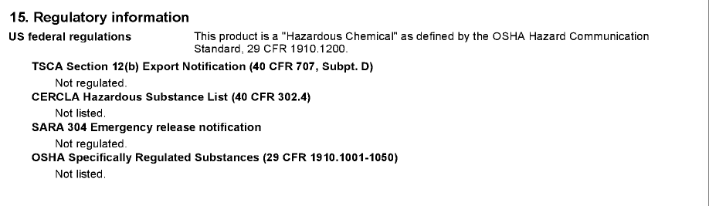
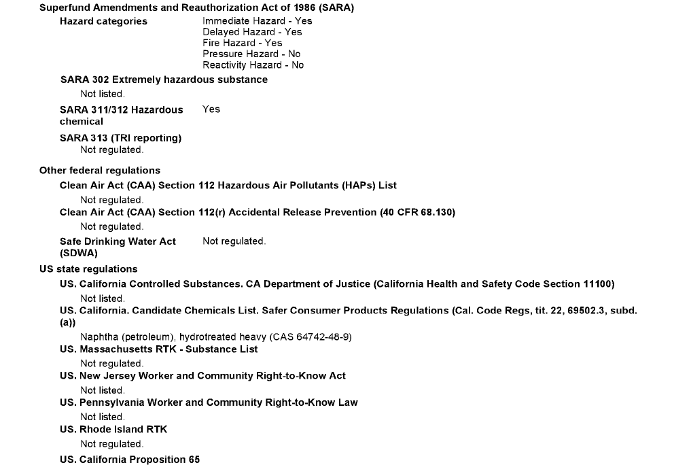
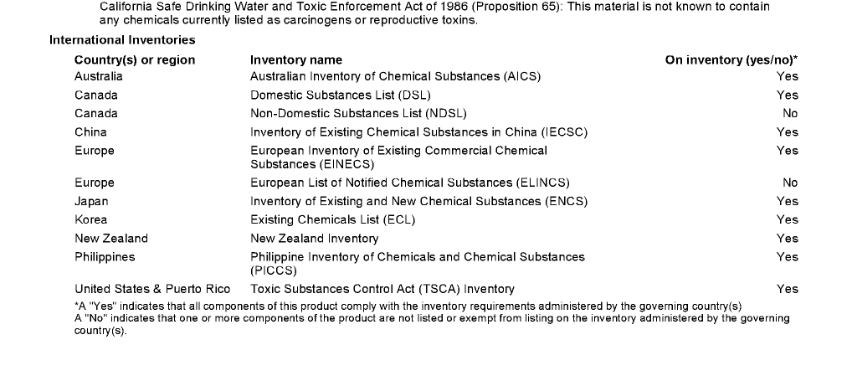
16. Other information

The information and recommendations contained herein are based upon data believed to be correct. However, no guarantee or warranty of any kind, expressed or implied, is made with respect to the information contained herein. We accept no responsibility and disclaim all liability for any harmful effects which may be caused by exposure to our products. Customers/users of this product must comply with all applicable health and safety laws, regulations, and orders.
HMIS Ratings Health: 2*
Flammability: 3
Physical Hazard: 0
NFPA ratings Health: 2
Flammability: 3
Instability: 0

Not Applicable

This is the first version in the GHS SDS format. Listings of changes from previous versions in other formats are not applicable.

End of Document

